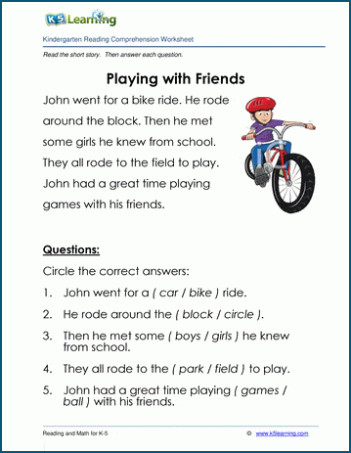

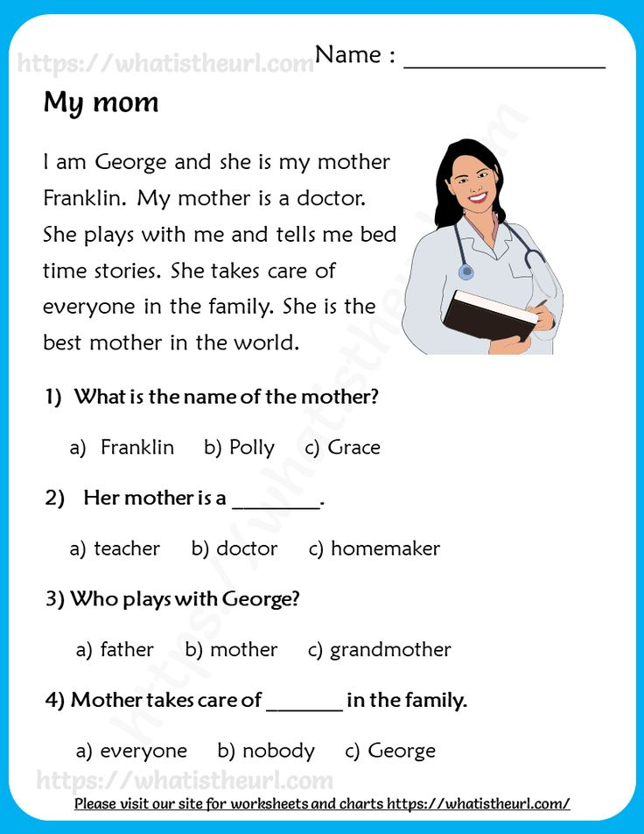

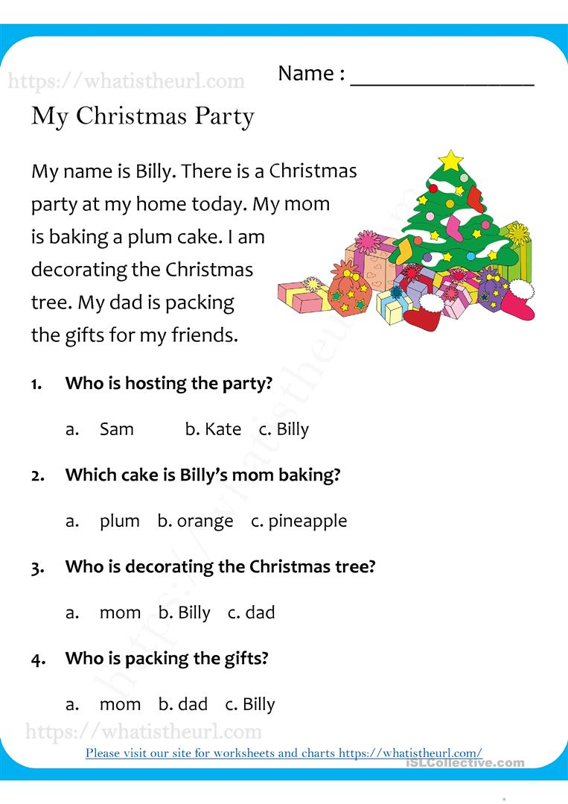

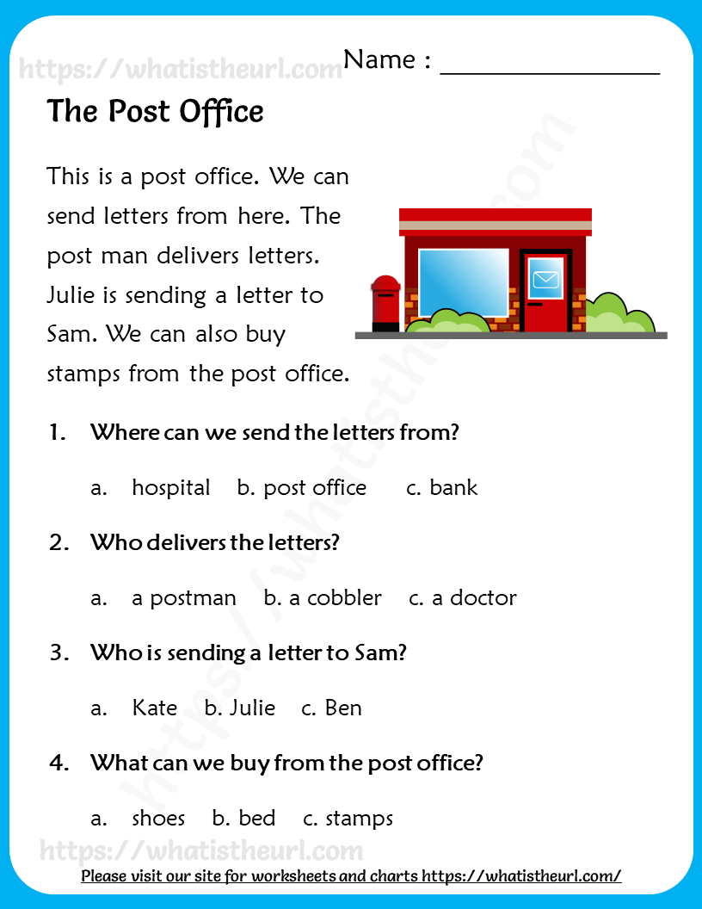

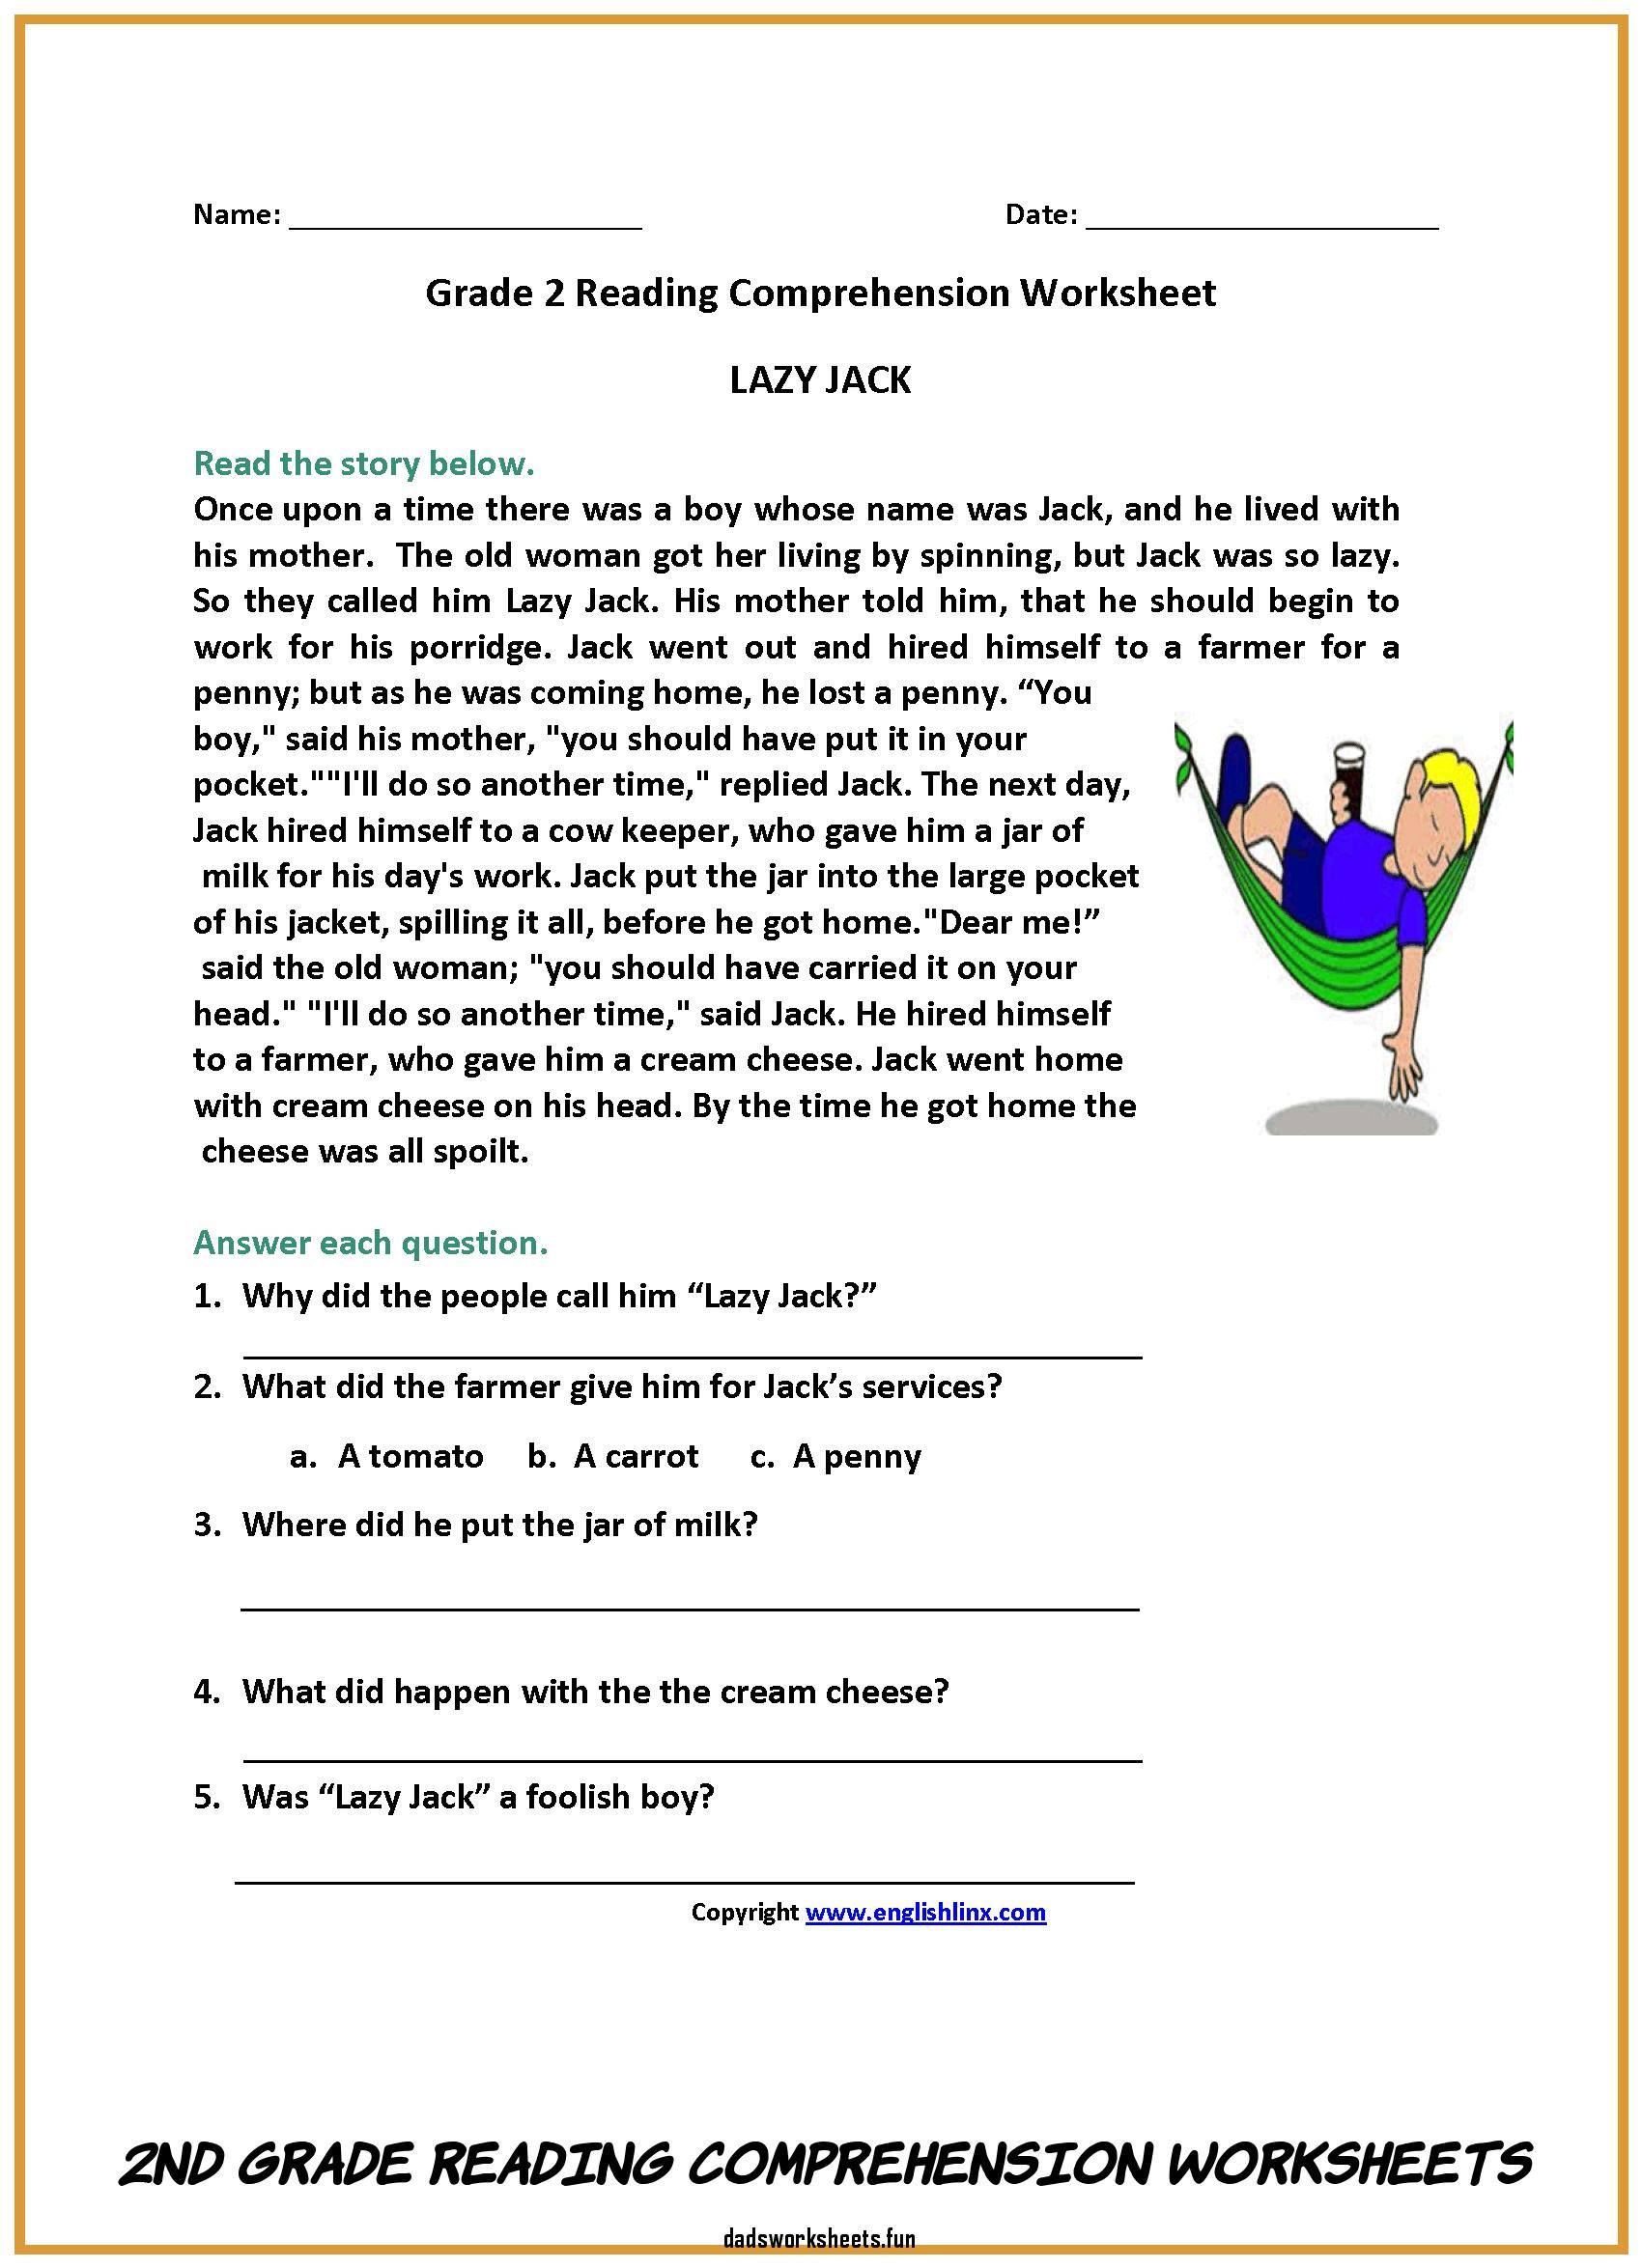

Verb and noun: <https://www.k5learning.com/free-grammar-worksheets/third-grade-3/verbs>

<https://www.youtube.com/watch?v=8irI5t3ZLPs> (verbs and noun

<https://www.youtube.com/watch?v=TWnHEioYqls> https://www.youtube.com/watch?v=gQsZr8yrsno